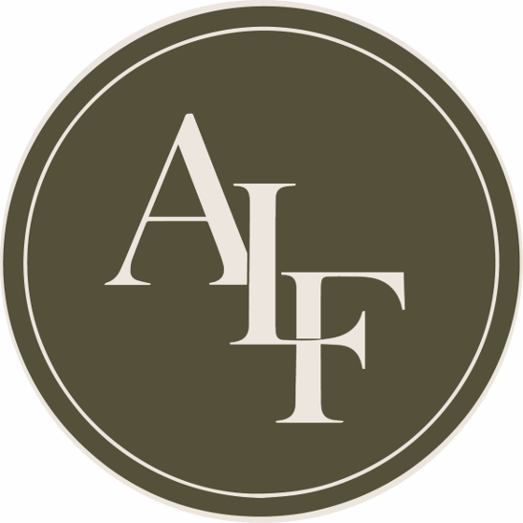

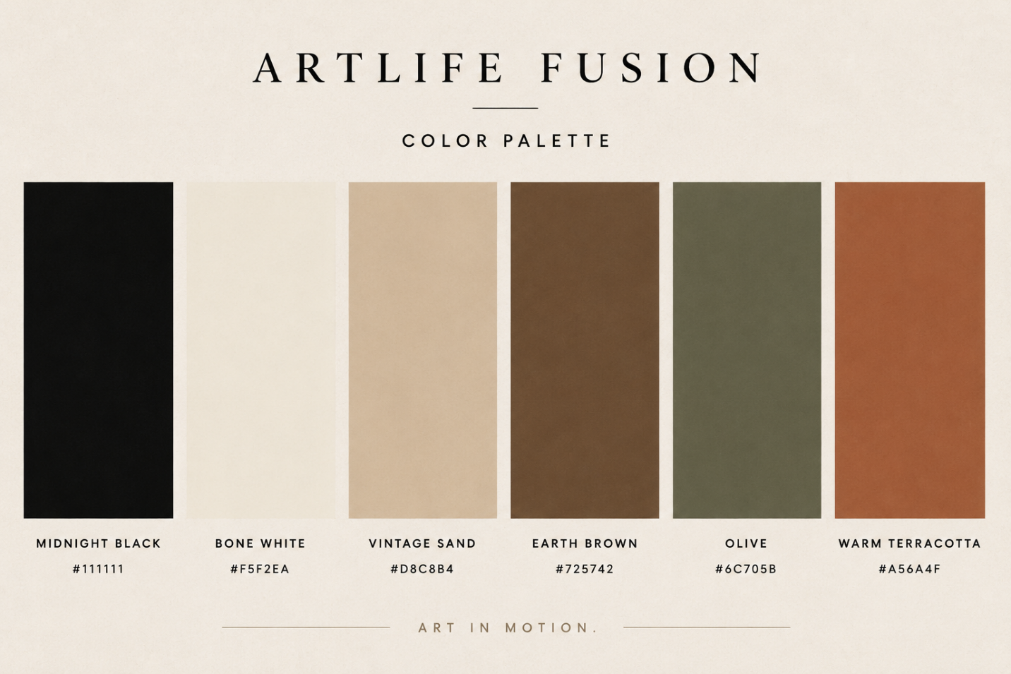
Introduction

I’m a visual artist and creative entrepreneur based in Kigali, Rwanda. I use art as a way to connect, inspire, and create opportunities, especially for children and young people. For almost a decade, I’ve been using painting, creative activities, and the TBRI approach to create spaces where children can feel safe, express themselves, build confidence, and discover their creativity. I also run a small creative studio where I paint, teach, exhibit, and collaborate with other artists. Through Artlife Rwanda, I’m exploring how art can grow beyond the canvas into workshops, exhibitions, creative products, branding, and opportunities for young artists.

My Artist Statement
I am Cedrick Gisimba, a Rwandan visual artist. I have been drawn to art since I was young. In high school, whenever I had free time, I would find myself drawing in my notebooks mostly faces, people I imagined, or characters from movies that caught my attention. At the time, I was simply enjoying creating. I did not know that it would eventually become such an important part of my life.
One moment that encouraged me to take art more seriously was a drawing competition at my school. I was chosen to represent the school, and being recognized for something I naturally enjoyed gave me confidence to keep going. Later, I made my first painting of my father. He liked it and encouraged me to have a space where I could continue creating. That small studio became the place where my practice grew, and it is still an important part of my work today.
Over the years, I have learned through different experiences. I enjoyed looking through art books and studying the work of artists from earlier generations. Their paintings helped me understand different ways of working with color, form, and technique and encouraged me to experiment. Trainings and relationships with other artists also opened my mind to different ways of thinking about art. All of these experiences have helped me slowly discover my own way of creating.
A lot of my work is inspired by children. They have been a big part of my life, and I have grown up seeing their different personalities, emotions, games, relationships, and everyday experiences. I am especially interested in the moments when children are simply being themselves playing, imagining, laughing, exploring, or expressing something without thinking about how they are being seen.
When I paint children, I am not only interested in capturing what they look like. I am interested in what I can feel or imagine behind the image their emotions, innocence, energy, dreams, and the possibilities that exist within them.
I mainly work with acrylic paint, using brushes and palette knives. I enjoy combining figurative painting with abstract marks, textures, and movement. Luminous colors are an important part of my work. They give my paintings more energy and make the figures feel alive, but they also mean something deeper to me. I use light as a symbol of hope and innocence. It represents the possibility and potential I see in children, even when their circumstances may not always be easy.
I also use abstraction because not everything we feel can be explained through a face or a realistic image. Sometimes a color, a texture, a mark, or a movement can say something that words cannot. I like leaving some space for the viewer to bring their own feelings and experiences into the work.
Art has changed the way I see the world. It has made me pay more attention to people, society, nature, and the small things around me that can easily be missed. When I am creating, I feel connected to myself. Painting gives me a way to process what I see and experience and turn it into something that others can see and feel too.
My work with children has become an important part of my artistic journey as well. I teach art to children, including those who may not have easy access to creative materials or opportunities. Through my experience with TBRI-informed approaches in the Gisimba After School programs, I have seen how art can help children express themselves, build confidence, develop imagination, and discover something they may not have known they could do.
For me, making art and sharing art are connected. I want to continue developing my own practice while also helping create more opportunities for young people to experience creativity. My hope is to contribute to a stronger art community in Rwanda and eventually connect with artists and communities beyond Rwanda.
At the heart of my work are children, light, emotion, and the freedom to create. I want my paintings to have beauty, but also to make people feel something, see something differently, or discover their own meaning within the work.

